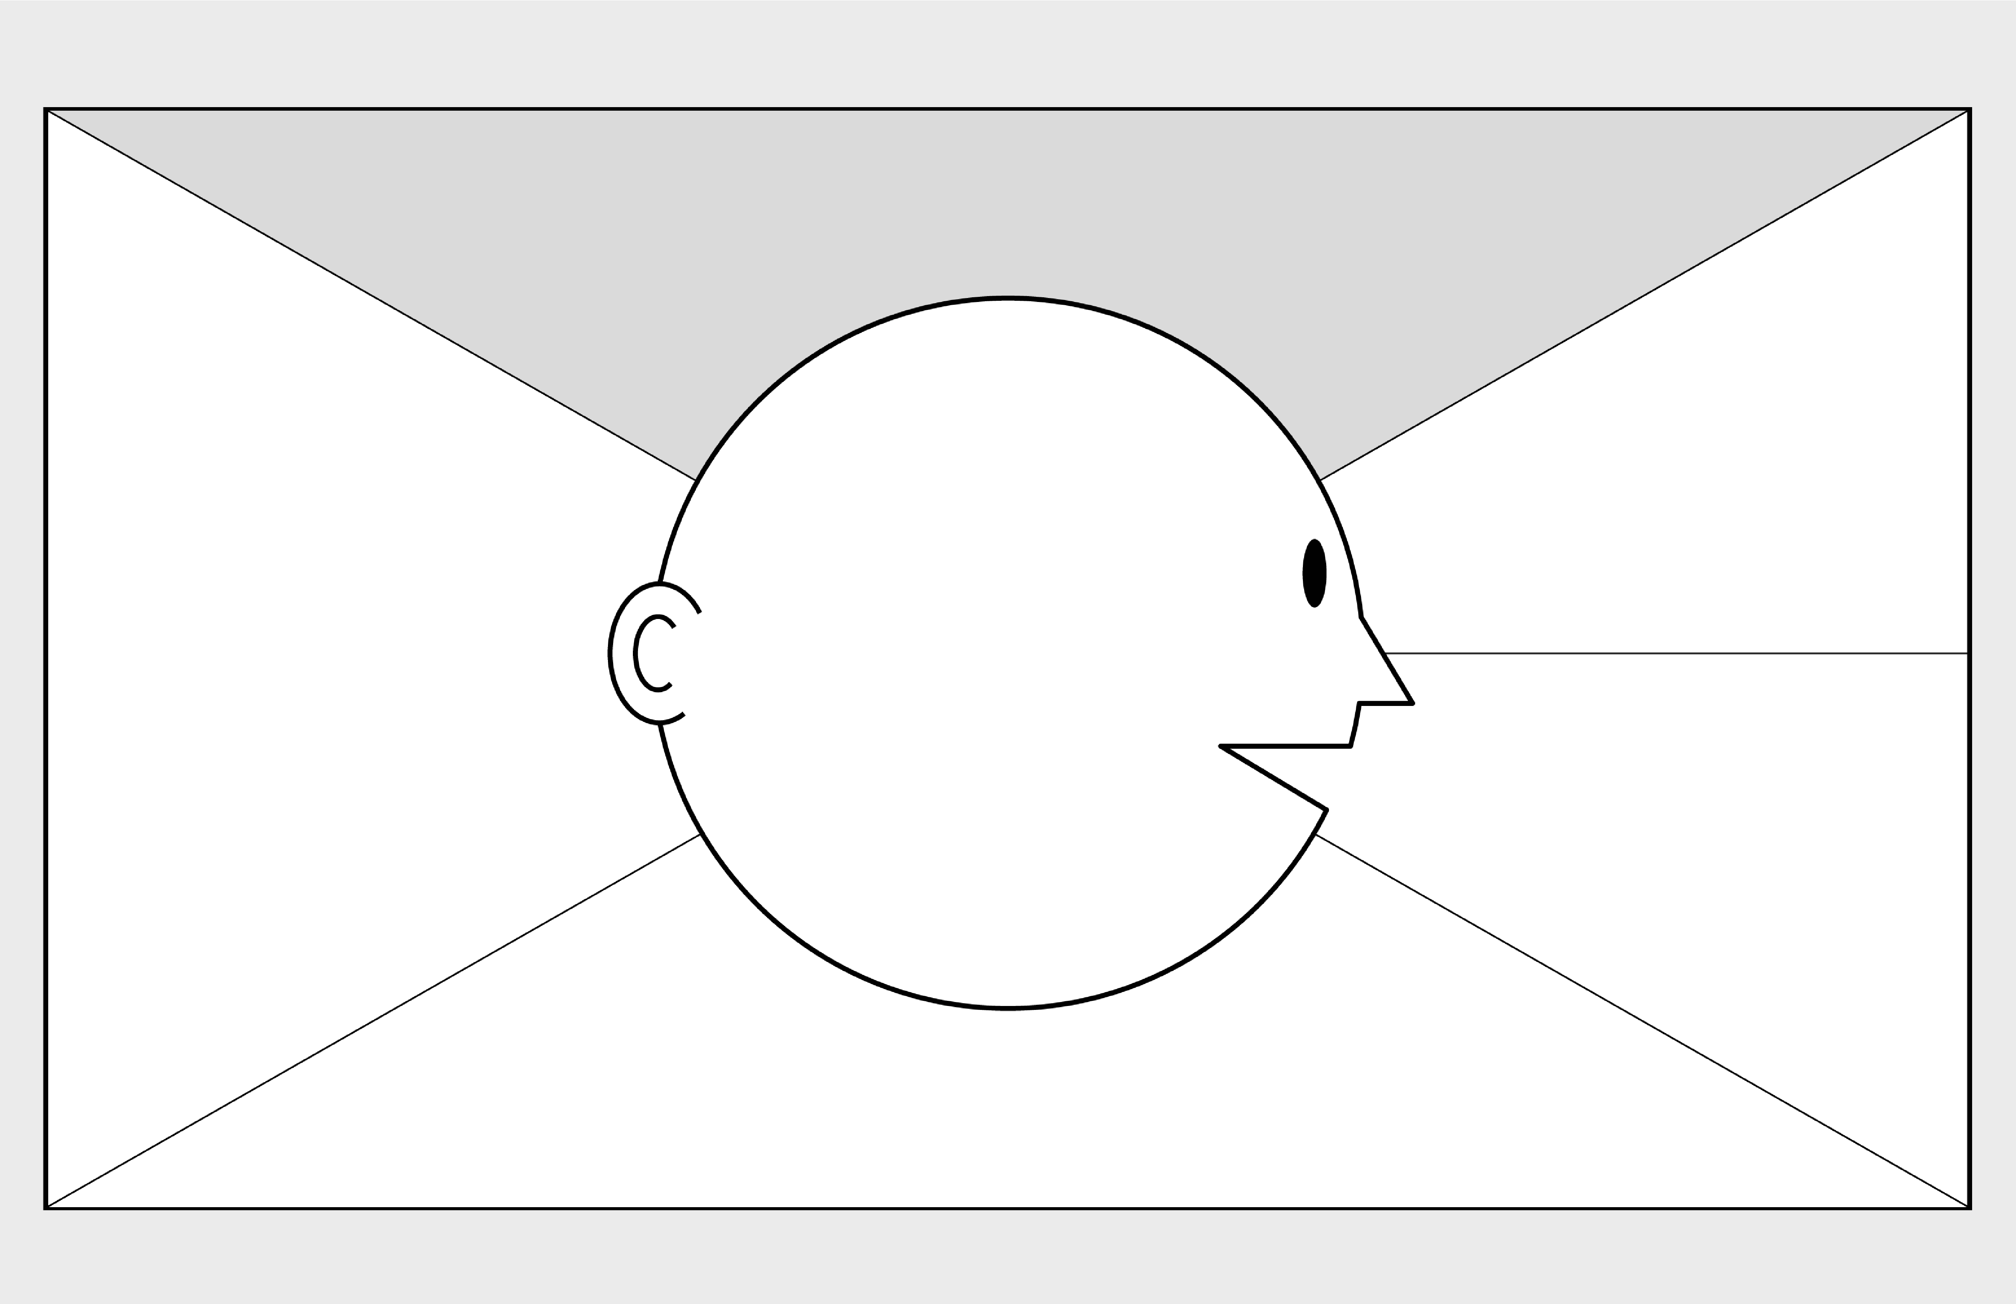

**Empathy Map Canvas**

*Designed for: RM*

*Designed by: YAN*

*Date:*

*Version:*

**WHO**

**are we empathizing with?**

**What do they need to DO**

**?**

What do they need to do differently?

Use the new information system tool to get the right customer to maximize the chances of successfully making a sale

What job(s) do they want or need to get done?

Pursue the customer to purchase the travel packages by giving the right and best information so that the customer are attracted.

What decision(s) do they need to make?

Is this the right customer for me?

How will we know they were successful?

The customer bought the travel package

Who is the person we want to understand?

Relation Manager

What is the situation they are in?

RM will not understand the all customer and wasted time on making those calls

What is their role in the situation?

Introduce and sell travel packages to customer as many as possible

**GOAL**

**What do they**

**SEE**

**?**

**What do they**

**SAY**

**?**

**What do they**

**DO**

**?**

**What do they**

**HEAR**

**?**

**What do they**

**THINK**

**and**

**FEEL**

**?**

What do they see in the marketplace?

Many users want to travel

What do they see in their immediate environment?

Holidays are coming

What do they see others saying and doing?

Many people want their trips organized and planned

What are they watching and reading?

Competitor’s advertisement

What have we heard them say?

It is time to gain more customer

What can we imagine them saying?

Hopefully, I can find more customer

What do they do today?

Call and receive call from potential customers

Advertised the holiday packages

What behavior have we observed?

It took a lot of time to make a sale

What can we imagine them doing?

Busy on selling their products

What are they hearing others say?

Is the holiday packages suit me?

What are they hearing from friends?

I went to Bali last week. The place is amazing

What are they hearing from colleagues?

I made a lot of sales today

What are they hearing second hand?

Other vendor holiday packages are cheaper

-

© 2017 Dave Gray, xplane.com

Last updated on 16 July 2017. Download a copy of this canvas at http://gamestorming.com/empathy

-

map/

**1**

**2**

**3**

**4**

**5**

**6**

**7**

**PAINS**

**GAINS**

What are their fears,

frustrations, and anxieties?

What are their wants,

needs, hopes and dreams?

What other thoughts and feelings might motivate their behavior?

* Attract many customers
* Customers are satisfied with his service and knowledge
* Customer bought the holiday packages
* Rude customers
* Calls are rejected
* Did not make any sales
* Unable to understand the need of the customer and as a result losing the customer